Homework 2
3.5-Code:
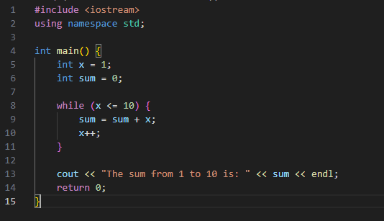
#include <iostream>
using namespace std;

int main() {
int x = 1;
int sum = 0;

while (x <= 10) {
sum = sum + x;
x++;
}

cout << "The sum from 1 to 10 is: " << sum << endl;
return 0;
}
3.5-Run
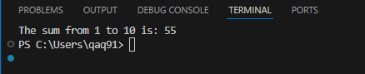
3.15-Code:
#include <iostream>
using namespace std;

int main() {
double sales;

cout << "Enter sales in dollars (-1 to end): ";
cin >> sales;

while (sales != -1) {
double salary = 200.0 + 0.09 * sales;

cout << "Salary is: $" << salary << endl;

cout << "Enter sales in dollars (-1 to end): ";
cin >> sales;
}

return 0;
}
#include <iostream>
using namespace std;

int main() {
double sales;

cout << "Enter sales in dollars (-1 to end): ";
cin >> sales;

while (sales != -1) {
double salary = 200.0 + 0.09 * sales;

cout << "Salary is: $" << salary << endl;

cout << "Enter sales in dollars (-1 to end): ";
cin >> sales;
}

return 0;
}
3.15-Run:
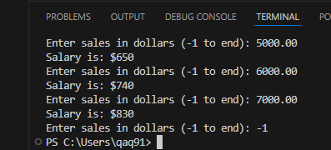

3.17-Code:
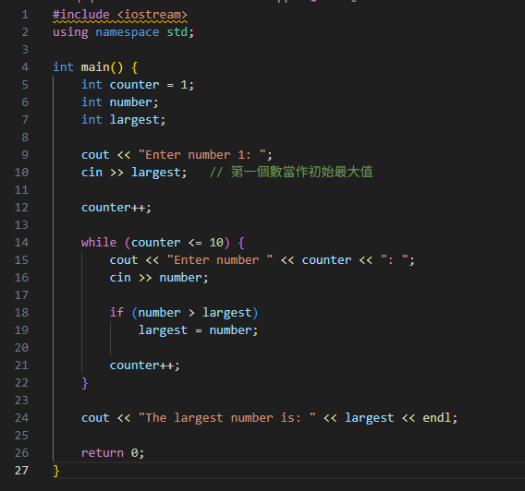
#include <iostream>
using namespace std;

int main() {
int counter = 1;
int number;
int largest;

cout << "Enter number 1: ";
cin >> largest; // 第一個數當作初始最大值

counter++;

while (counter <= 10) {
cout << "Enter number " << counter << ": ";
cin >> number;

if (number > largest)
largest = number;

counter++;
}

cout << "The largest number is: " << largest << endl;

return 0;
}
3.17-Run:
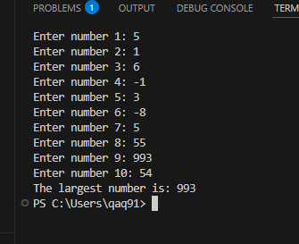

3.23 Code(a-1):
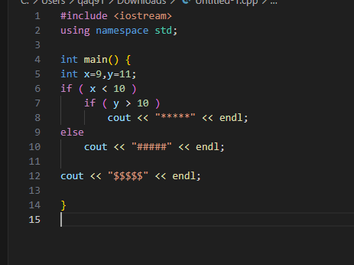
3.23 Run(a-1):
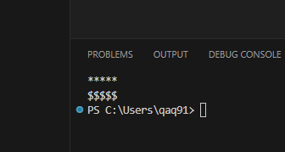

3.23 Code(a-2):
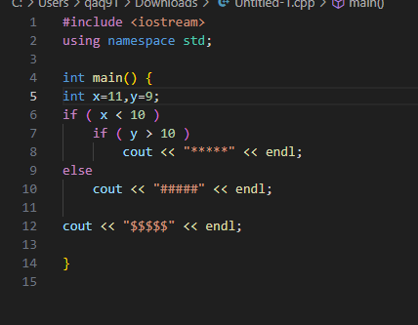
3.23 Run(a-2):
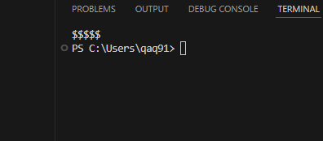
3.23 Code(a) Non Pre-Value:
#include <iostream>
using namespace std;

int main() {
int x,y;
if ( x < 10 )
if ( y > 10 )
cout << "*****" << endl;
else
cout << "#####" << endl;

cout << "$$$$$" << endl;

}
3.23 Code(b-1):
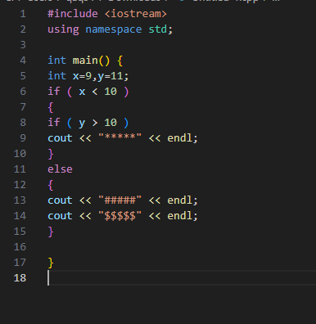
3.23 Run(b-1):
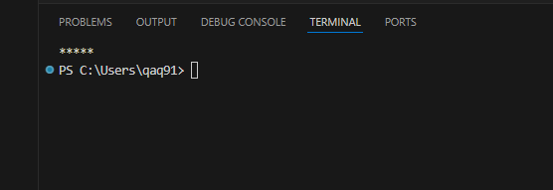

3.23 Code(b-2):
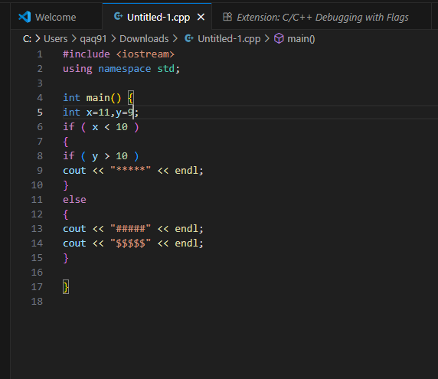
3.23 Run(b-2):
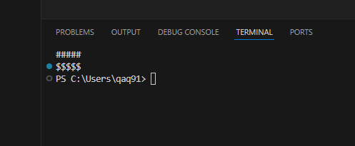
3.23 Code(b) Non Pre-Value:
#include <iostream>
using namespace std;

int main() {
int x,y;
if ( x < 10 )
{
if ( y > 10 )
cout << "*****" << endl;
}
else
{
cout << "#####" << endl;
cout << "$$$$$" << endl;
}

}

3.25 Code:
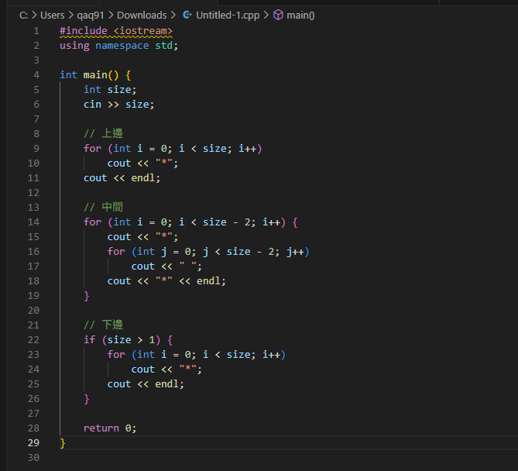
#include <iostream>
using namespace std;

int main() {
int size;
cin >> size;

// 上邊
for (int i = 0; i < size; i++)
cout << "*";
cout << endl;

// 中間
for (int i = 0; i < size - 2; i++) {
cout << "*";
for (int j = 0; j < size - 2; j++)
cout << " ";
cout << "*" << endl;
}

// 下邊
if (size > 1) {
for (int i = 0; i < size; i++)
cout << "*";
cout << endl;
}

return 0;
}
3.25 Run:
